Project: Gym Website for Starters

Home Page

*Functionality*

* Navigation Bar
* Carousel [Display Purpose]

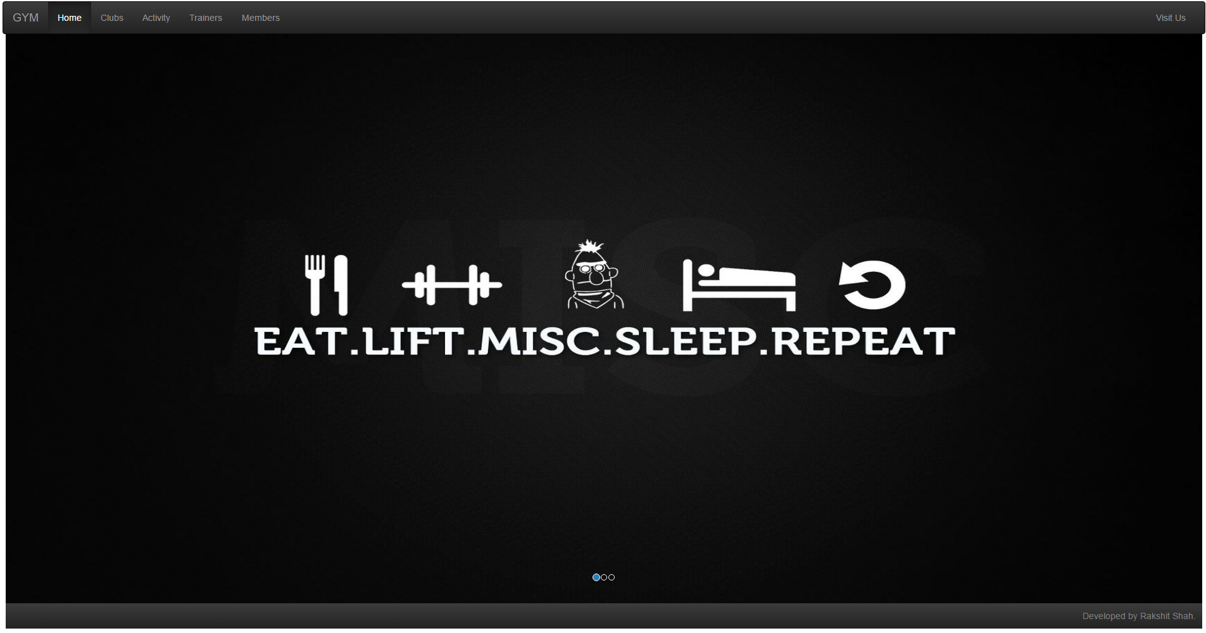

Clubs Page

*Functionality*

* Provides list of Equipments in a club.

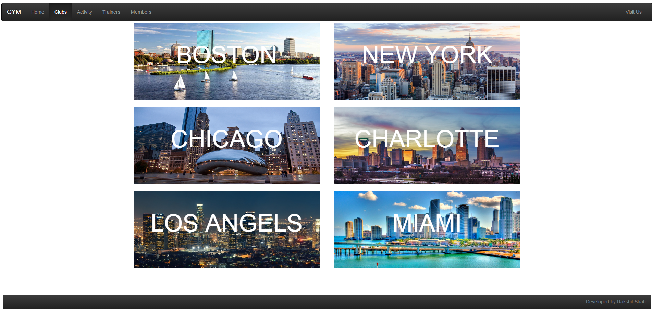

Equipment Pop up

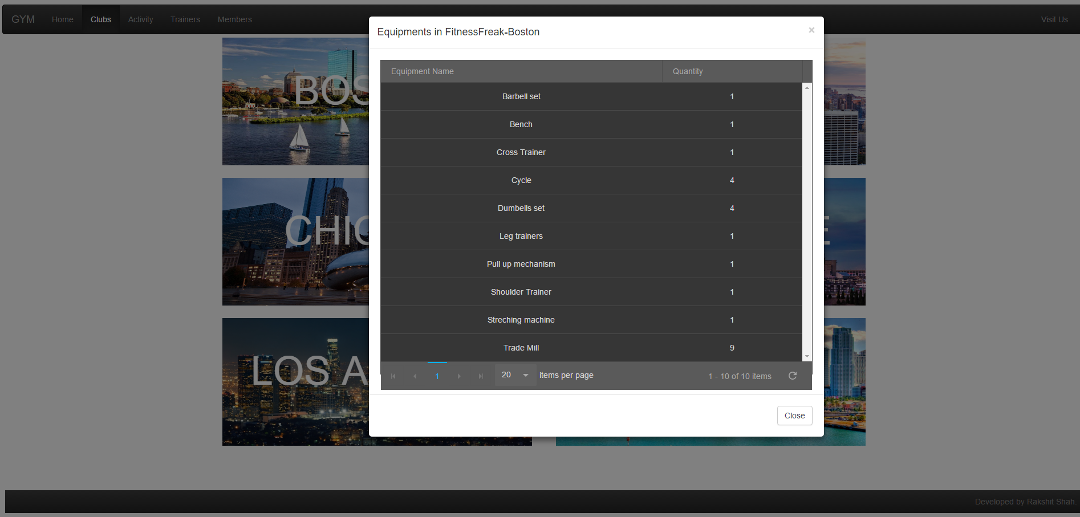

Activity Page

*Functionality*

* Detailed schedule of each gym.
* Grouped by club and day

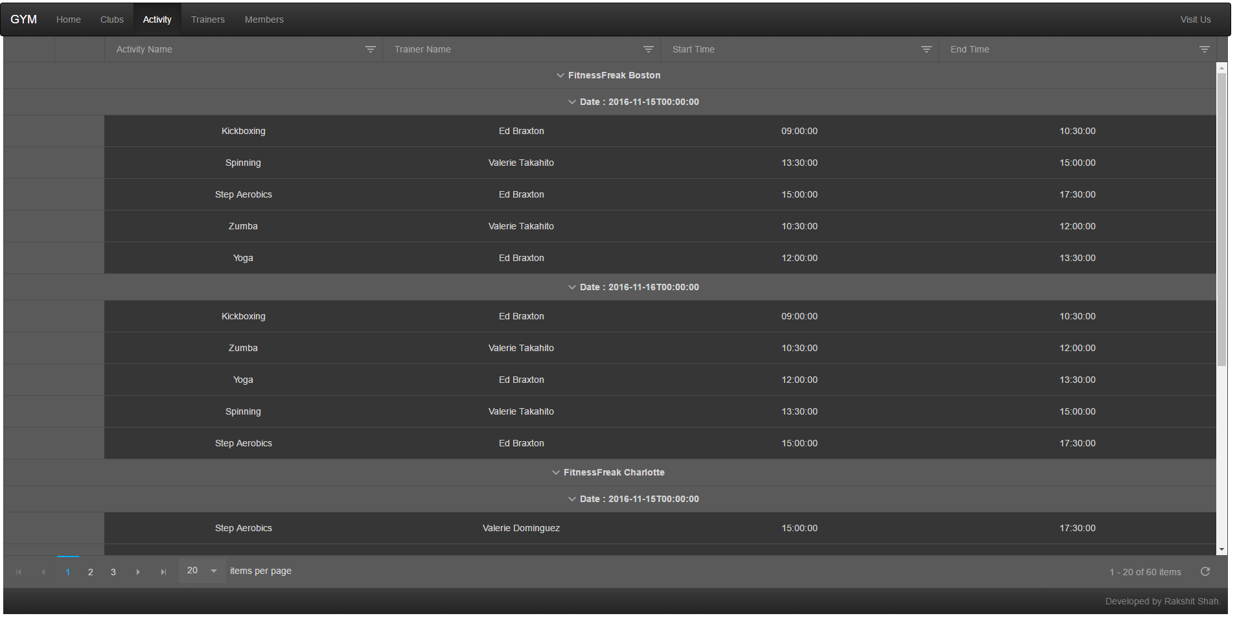

Trainers Page

*Functionality*

* Includes details of all the trainers
* Includes a functionality to train with trainers

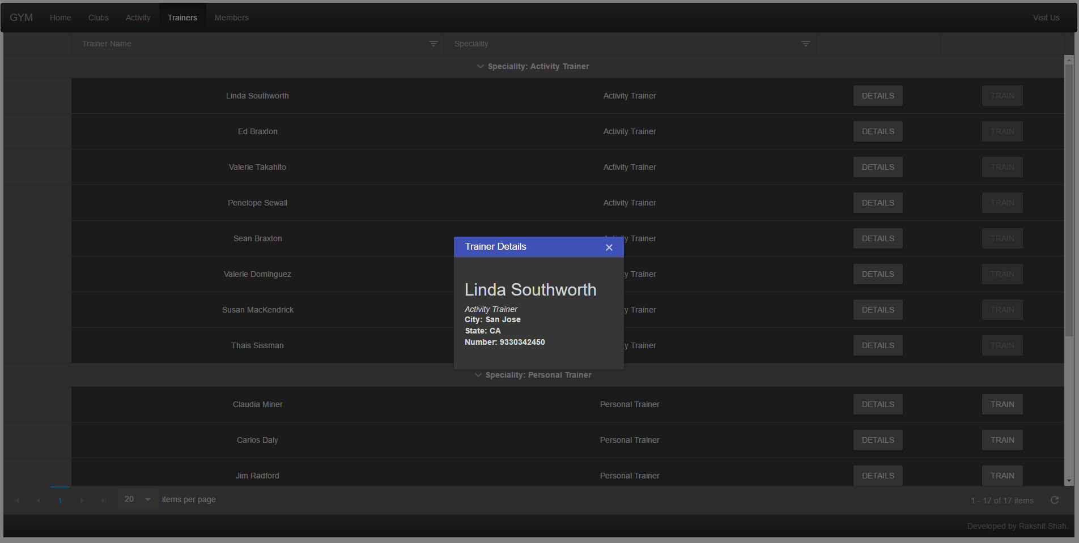

Trainer booking pop up

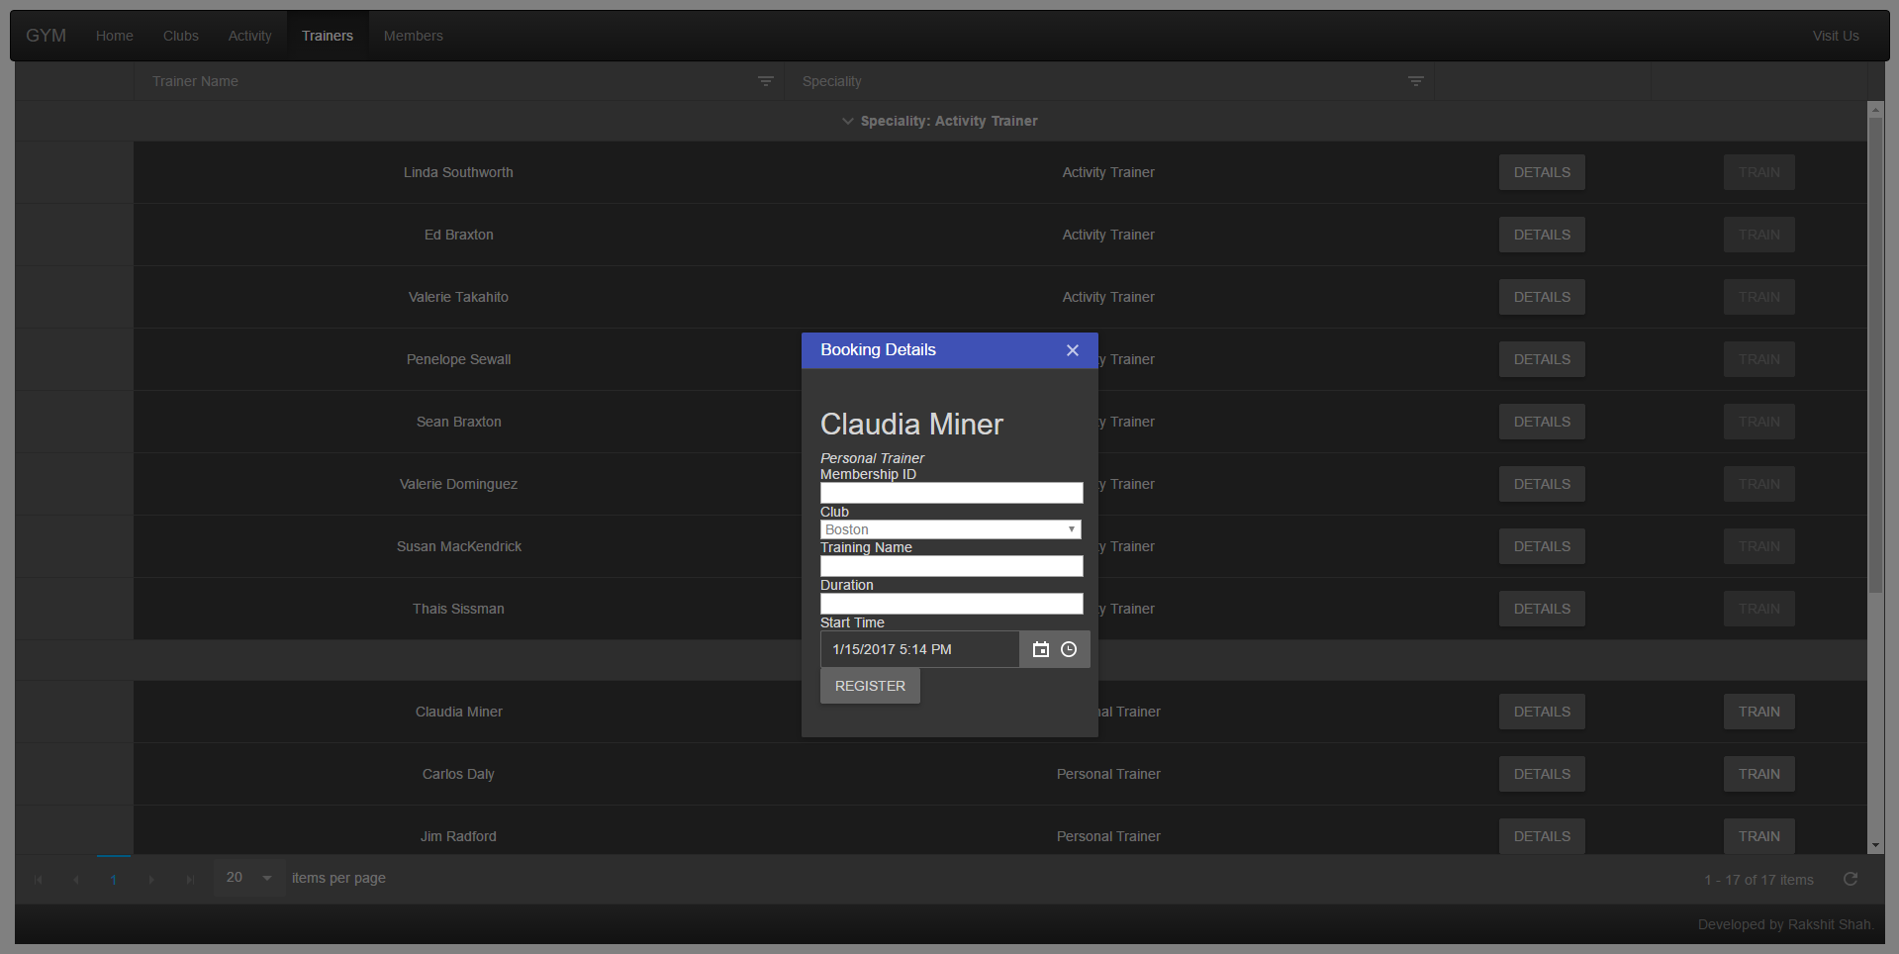

Members Page

*Functionality*

* Add, Update, Remove Member Details

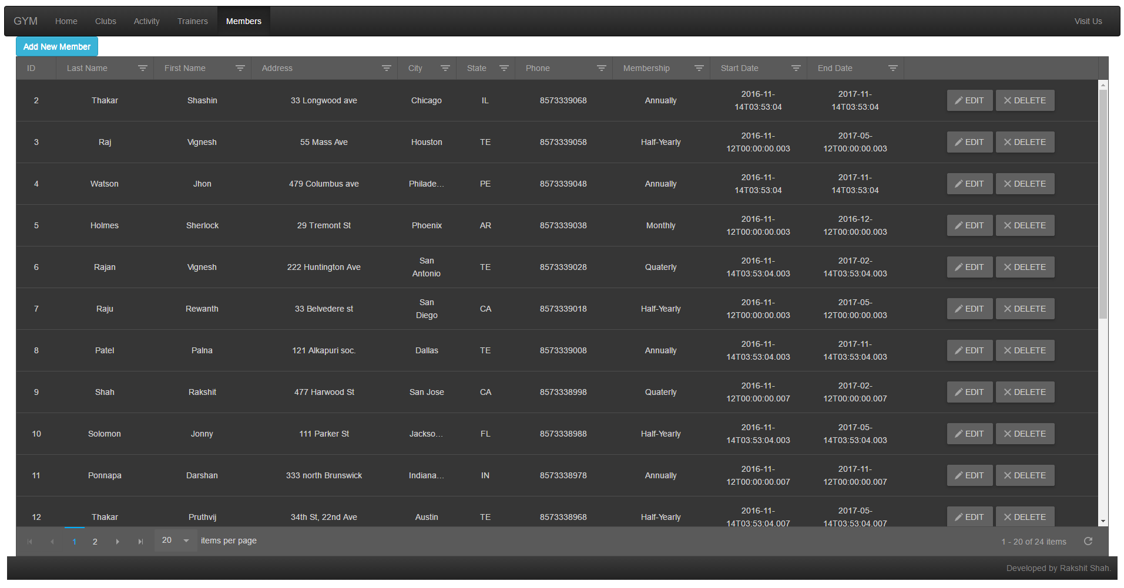

Add Member

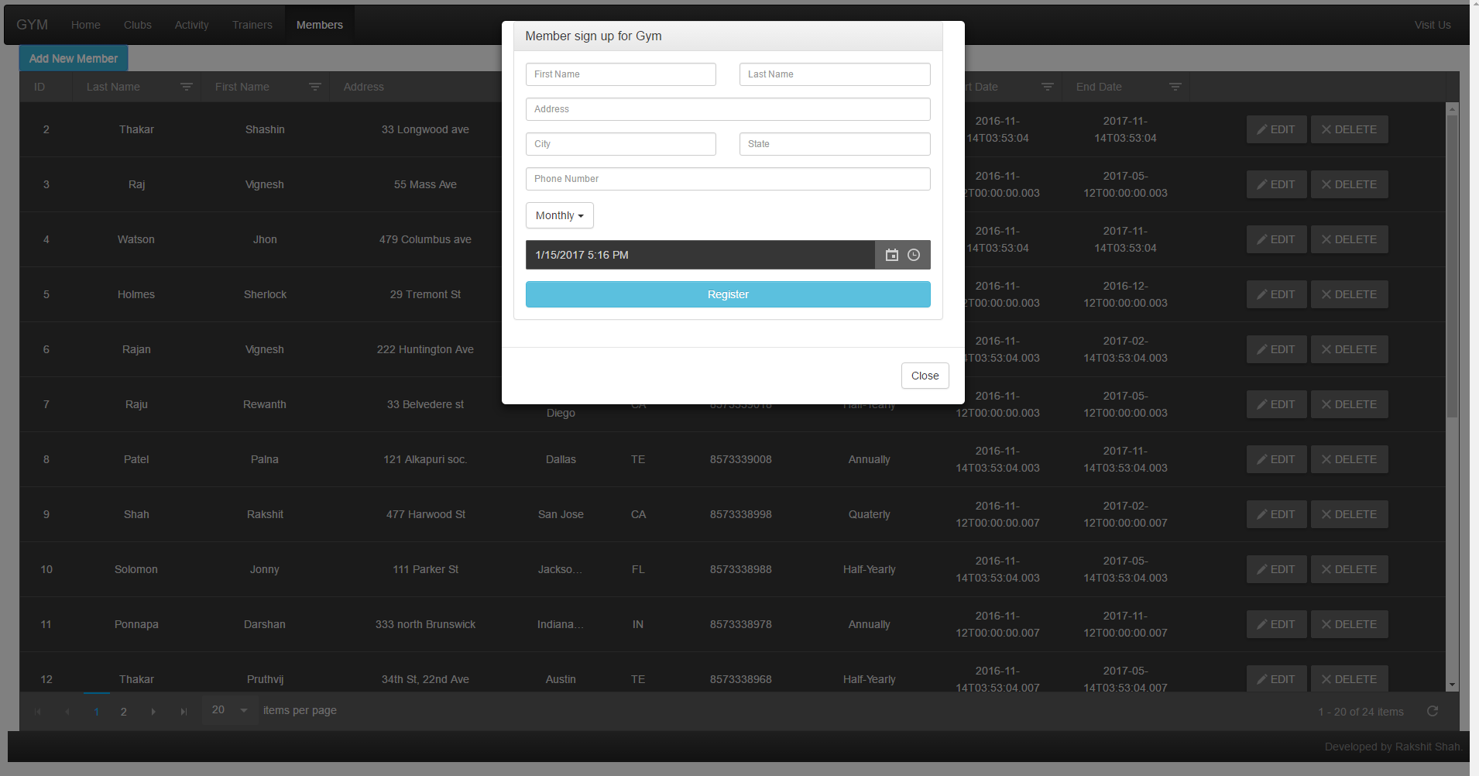

Inline Editing of Member

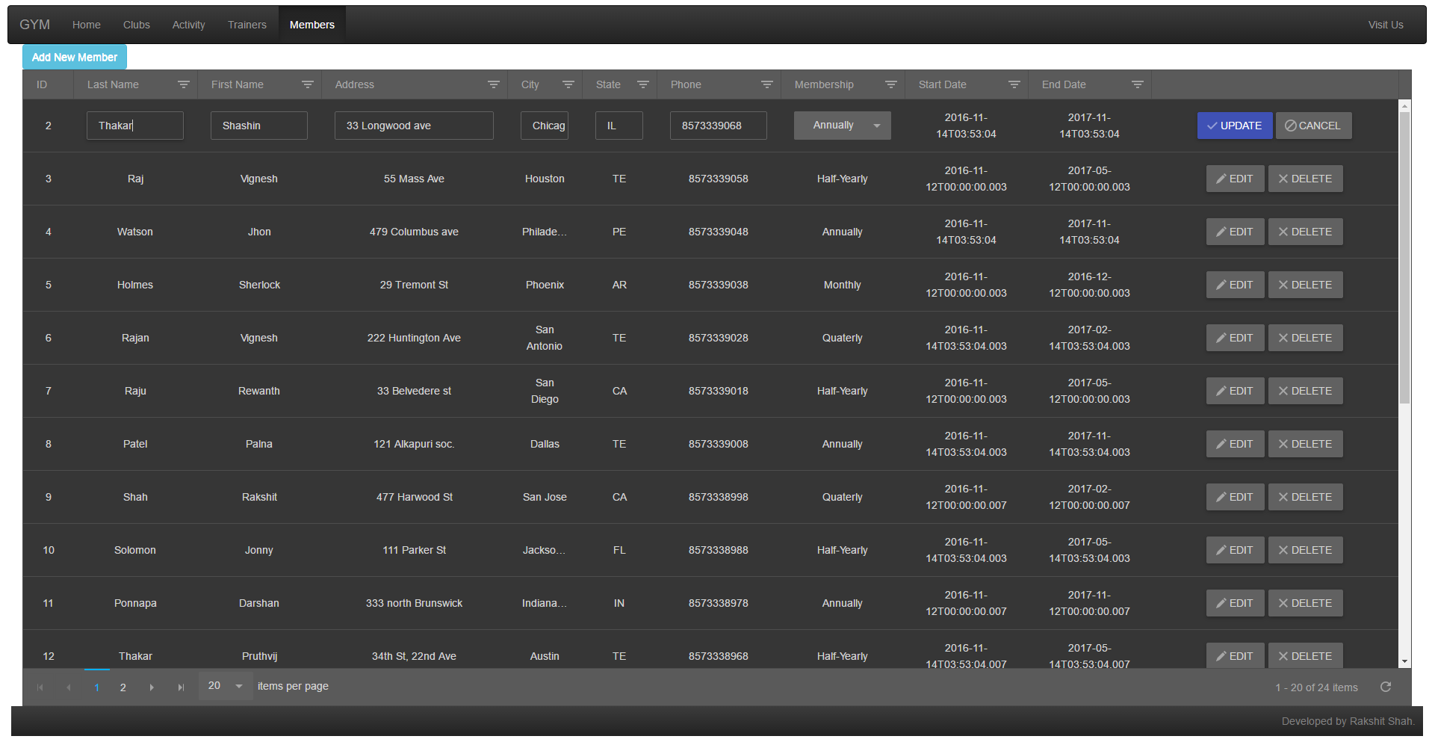

References:

<http://demos.telerik.com/kendo-ui/grid/index>

http://maxcdn.bootstrapcdn.com/

http://cdnjs.cloudflare.com